**EcoMauá 2025 Prototype Vechicle - Energy supply diagram:**

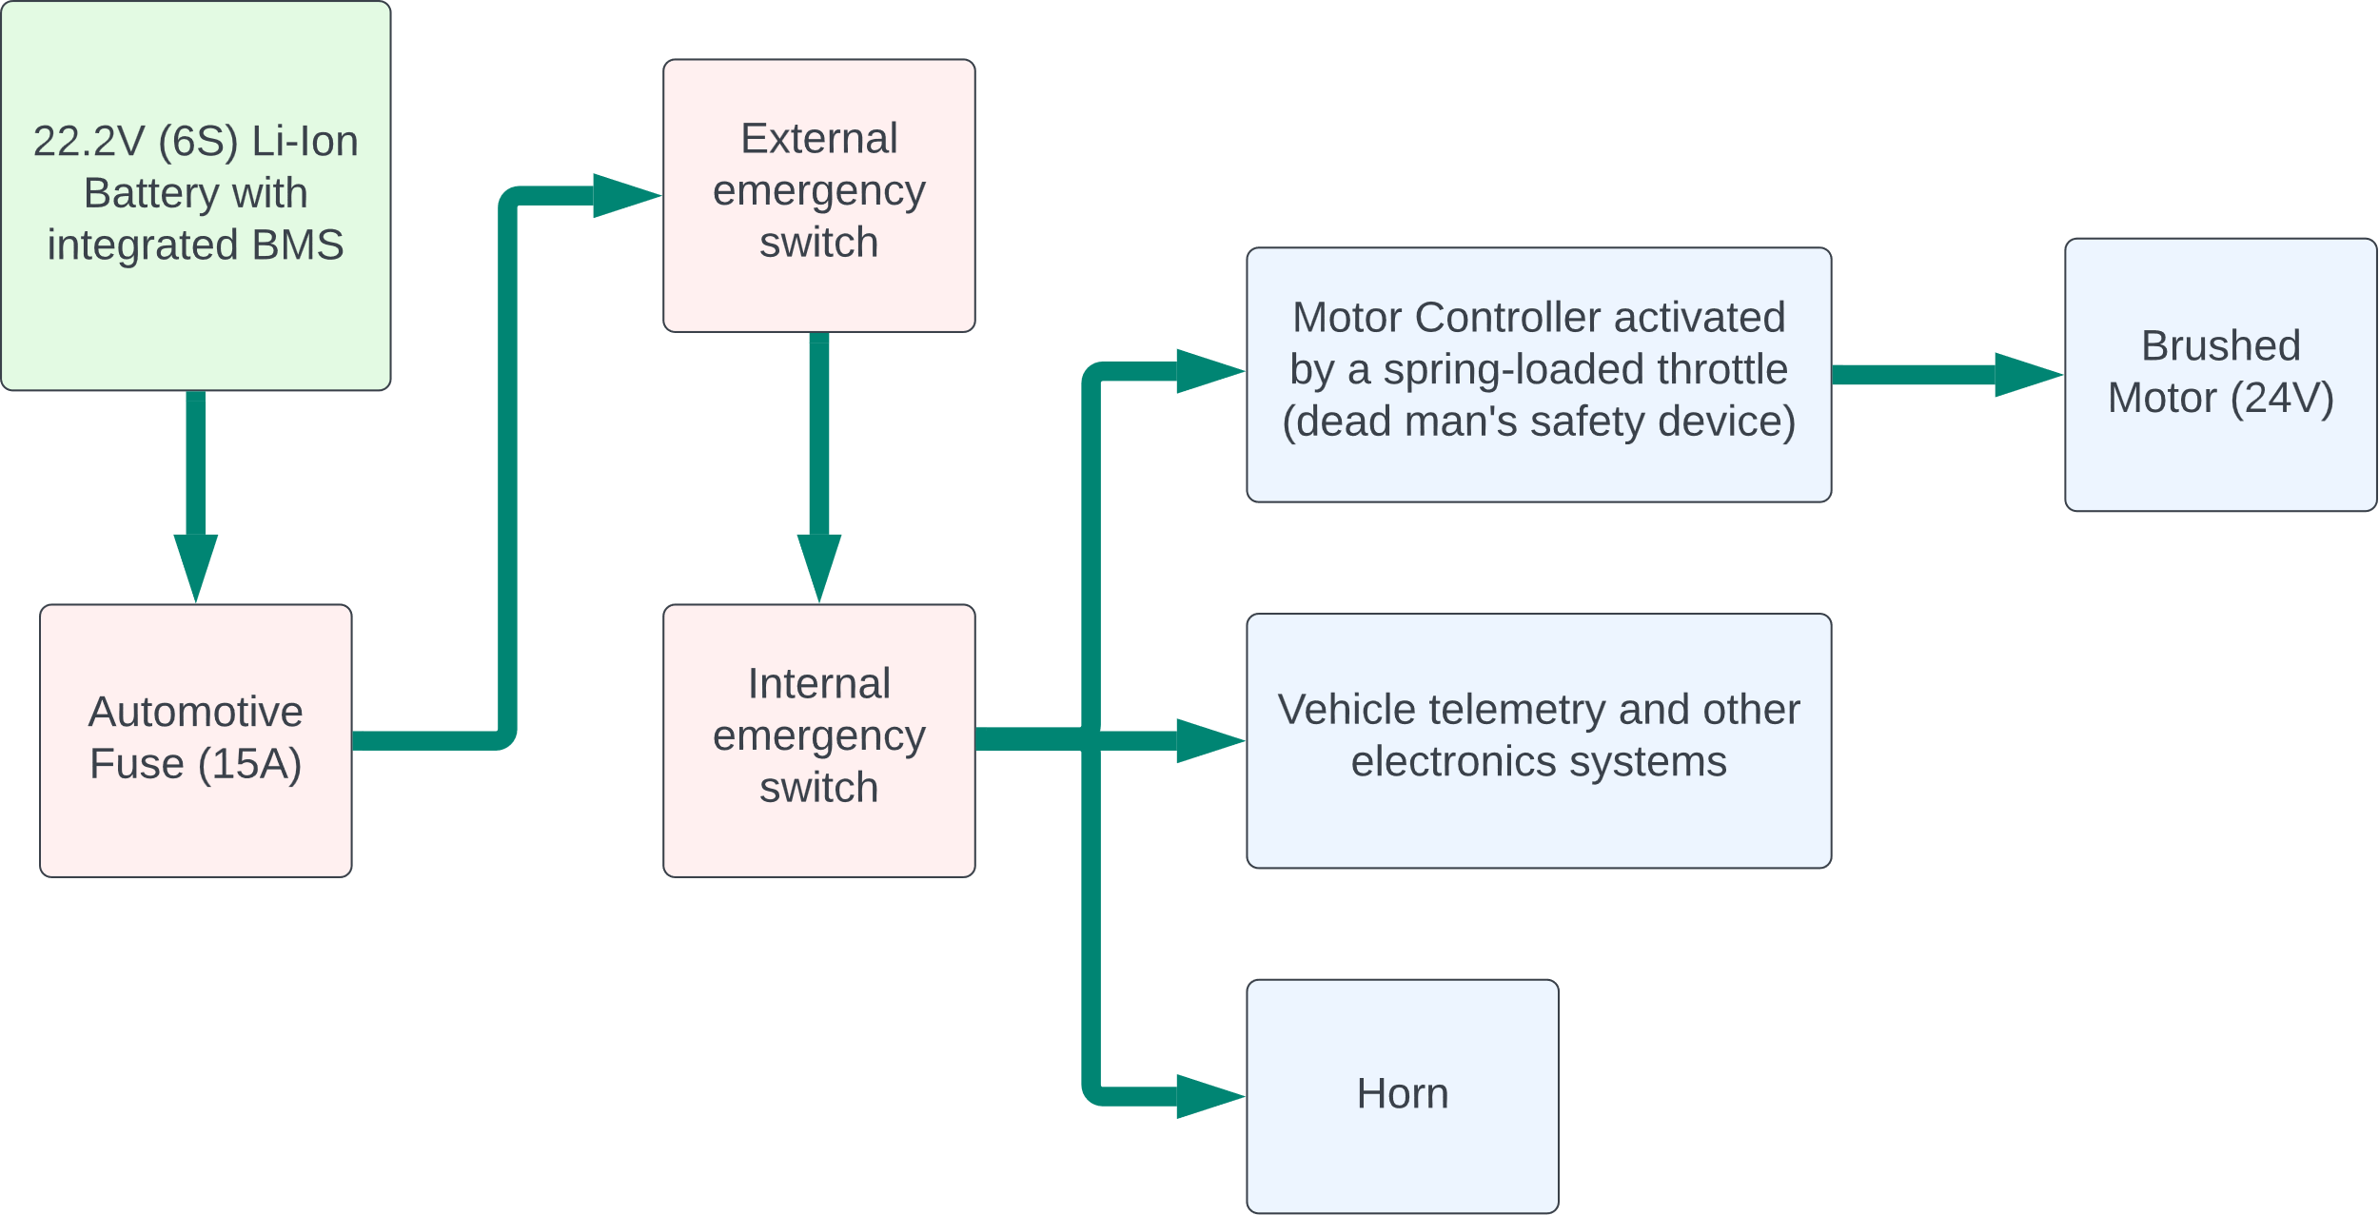

**EcoMauá 2025 Prototype Vechicle - Propulsion system diagram:**

